**Intertest IMP Points**

* **Press F10** for line by line processing
* Press **F5** for break point execution.
* For placing a break point press **U** in the line to create a breakpoint.
* Press **D/X** to delete a break point in the break point line
* Press **ABEND** in the command line and then **0** to come out of debugging
* **K** WS-TO-DATE to find the variable value

**D** WS-TO-DATE to display variable name

**F2** display in hex code format.

* **X** to delete the Variable display
* **V** WS-TO-DATE -> creates break point upon change of the variable value
* **?** restart the test from the beginning
* **LIST=JRCC040** -> login to CICS region and give this command to enter Intertest
* Processor option to compile inorder to debug in Intertest **GCOBC02**

**CLST.TRK644.SCL(ADD)**

* After compilation we have to NEWC the program

CNTL=NEW,PROG=JRCC040

* Remove OR CLEAR all breakpoints for a program **CNTL=OFF,PROG=JCCC080**
* **RUN** in command line and enter to skip all breakpoints
* **TSO PROTSYM** some times intertest file (NETTV.CICS.TN.PROTSYM.CL) has space problems due to large no of programs using it. By deleting the old programs by age we can solve this issue.
* Go to specific line press **G** before the line



* Modify values of a variable Press **K varname** then **type in the value** you wish to change.

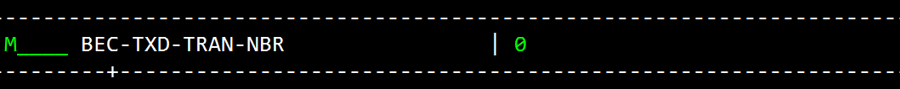

* **For Backtracing F11** from the break point where you want to activate backtracing.

Then remove * from last statement and **press F2**. Now to back trace line by line **press F11**

Now disable back trace by pressing **F2** then remove * and **F3** now you press **F10** for moving forward

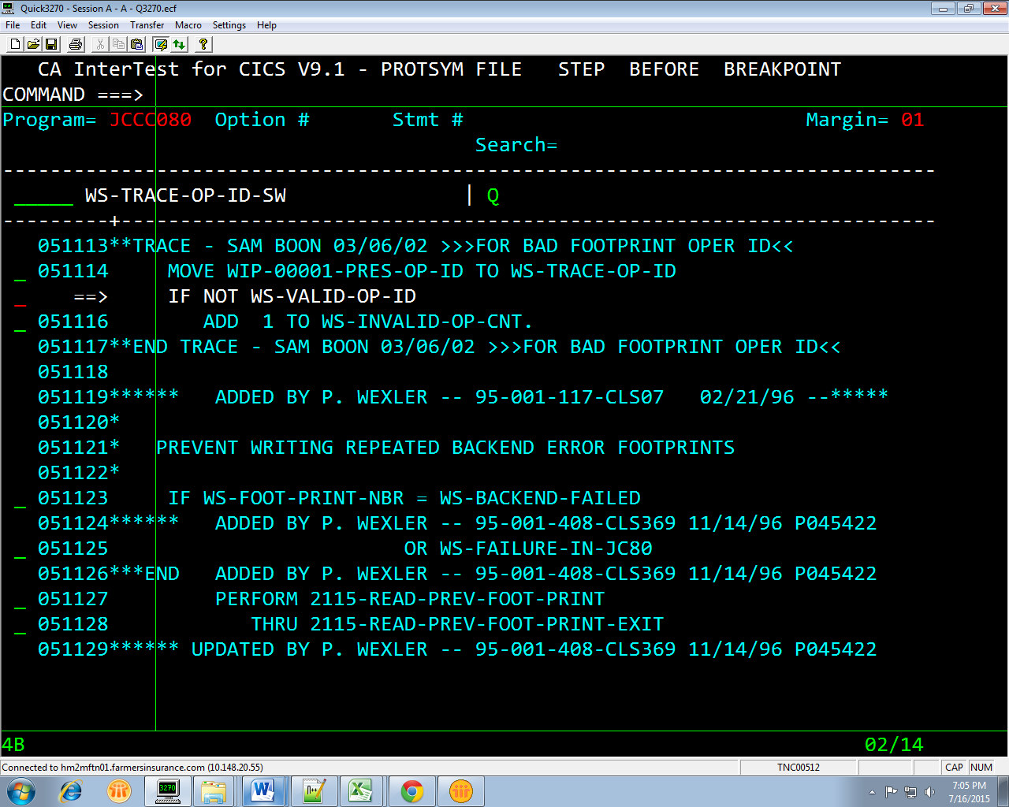

Delete * and then press enter then **press F2**

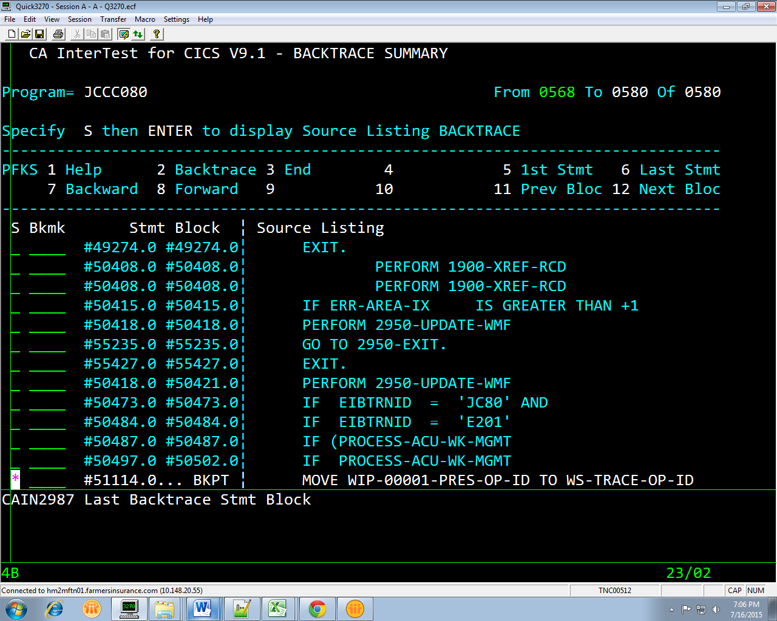

|  |
| --- |
|  |

* **Setting up Backend Break point**

**Press CNTL then give options as shown in figure**

**ITS better to give newcopy of the program before giving unconditional brk point**

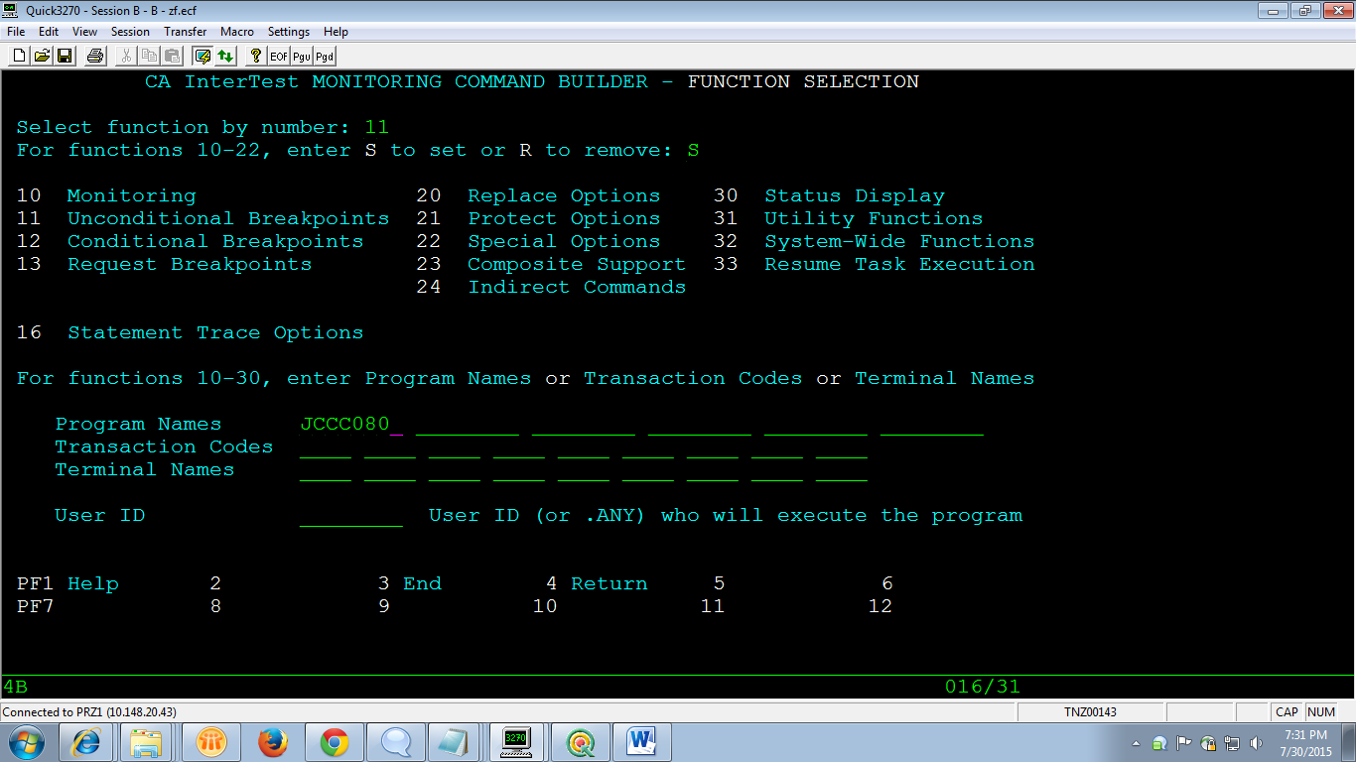

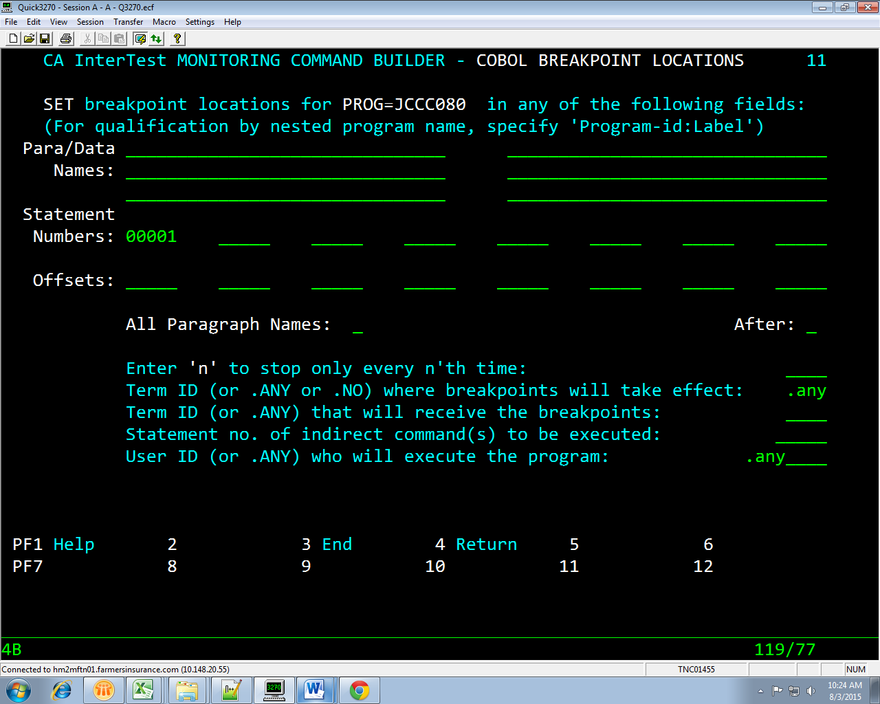

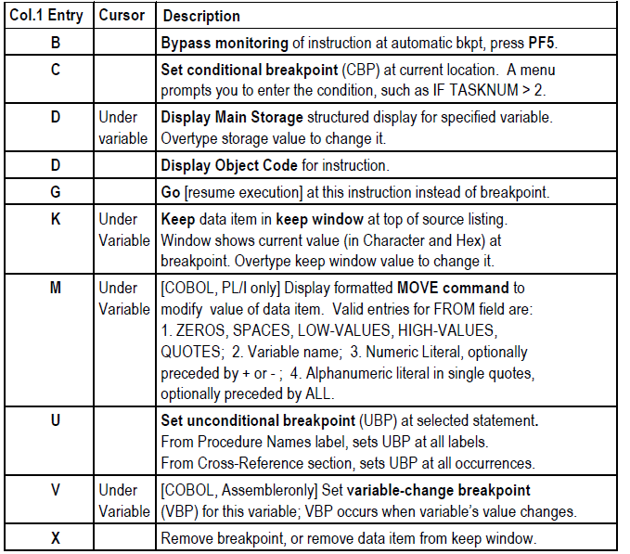

**RAJU VANGA**

1. ADD (fresh adding) / GENERATE(means recompile) Online (COBC) ELEMENT(with PROCESSOR GROUP : GCOBC02) to CPRTEST1 (DEV environment)

2. Then, Login to TS41 Region , give below command

LIST=JCCC080 (LIST=Program Name)

3. Once Program code appears, go to Procedure Division and set BreakPoint with line command 'U'.

U for Set Break Point

X for Removing Break Points

4. To debug the program in intertest, clear screen and enter the main transaction… and keep entering the data until you get your transaction.

5. To come out of Intertest use below command.

CNTL=OFF,PROG=JCCC080

6.

F10 for Line by Line Execution

F5 is for MOVE Break Point to Break Point

7. Use below commands

K for Keep Variables(to keep/display value, also you can update these values)

D to display all the values in table

TYPE THE BELOW OPTION NUMBER, IT WILL TAKE TO THE Corresponding paragraph.

COMMAND ===>

Program= JCCC080 Option # Stmt #

OPTS 1 Proc div 2 Work-stor 3 Link sect 4 D-map 5 Clst/Pmap More: +

6 Data xref 7 Proc xref 8 Err msgs 9 Srch fwd 10 Srch bwd

8. Below Not Related to INTERTEST, But , useful commands

NEW COPY OF PROGRAM

cntl=new,prog=jccc080

cemt set prog(jccc080) ne

**Mail DATA**

1. ADD (fresh adding) / GENERATE(means recompile) Online (COBC) ELEMENT(with PROCESSOR GROUP : **GCOBC02**) to CPRTEST1 (DEV environment)

2. Then, Login to TS41 Region , give below command

LIST=JCCC080 (LIST=Program Name)

3. Once Program code appears, go to Procedure Division and set BreakPoint with line command 'U'.

U for Set Break Point

X for Removing Break Points

4. To debug the program in intertest, clear screen and enter the main transaction… and keep entering the data until you get your transaction.

Once your screen flow came, it will stop at the where you set your Break Point.

5.

F10 for Line by Line Execution

F5 is for MOVE Break Point to Break Point

6. To come out of Intertest use below command.

CNTL=OFF,PROG=JCCC080

7. Use below commands

K for Keep Variables(to keep/display value, also you can update these values)

D to display all the values in table

8. Give below Mentioned Option Values, you will be transferred to that place.

TYPE THE BELOW OPTION NUMBER, IT WILL TAKE TO THE Corresponding paragraph.

COMMAND ===>

Program= JCCC080 Option # Stmt #

OPTS 1 Proc div 2 Work-stor 3 Link sect 4 D-map 5 Clst/Pmap More: +

6 Data xref 7 Proc xref 8 Err msgs 9 Srch fwd 10 Srch bwd